**Performance Test Report**

**For**

**Execution of**

**Registration-Processor Packet Upload – 100 packets**

Date: 18 November 2019

Author: Gaurav Sharan

**Summary**

This report presents the observations and findings of the load test conducted for uploading and processing 100 packets in registration processor module.

The objective of this load test was to observe and record the behavior of the application when 10 concurrent users upload 10 packets each to the registration processor packet receiver component.

Below are the scenario details:

|  |  |
| --- | --- |
| **Report Name** | Reg-Processor Packet Upload |
| **Run Date** | 18-November-2019 |
| **Period (Accessing Packet Upload APIs)** | 06:50:00 AM to 06:57:02 AM(UTC) |
| **Period (Packet processing)** | **06:50:00 AM to 08:15:30 AM (UTC)** |
| **Packet Upload Methodology** | Sync & packet upload APIs exposed by the Registration Processor module |
| **Number of packets uploaded/processed** | 100 |
| **Number of concurrent users** | 10 (threads uploading packets) |
| **Ramp up** | 10 users in 60 seconds |
| **Run Duration** | NA |
| **Ramp down** | NA |

**Cell Configuration used for testing**

|  |  |  |  |
| --- | --- | --- | --- |
| **Machines** | **#Cores** | **RAM (GB)** | **Disk (GB)** |
| **aks-agentpool-32091406-0** | 2 | 8 | 100 |
| **aks-agentpool-32091406-1** | 2 | 8 | 100 |
| **aks-agentpool-32091406-2** | 2 | 8 | 100 |
| **aks-agentpool-32091406-3** | 2 | 8 | 100 |

The transaction response times observed were as below:

|  |  |  |  |  |  |  |  |
| --- | --- | --- | --- | --- | --- | --- | --- |
| **Label** | **# Samples** | **Average(ms)** | **90% Line(ms)** | **Min(ms)** | **Max(ms)** | **Error %** | **Throughput** |
| **TR_regproc_authentication** | 100 | 1136 | 2308 | 31 | 7047 | 0.00% | 0.257 |
| **TR_regproc_encrypt** | 100 | 31 | 41 | 23 | 67 | 0.00% | 0.25701 |
| **TR_regproc_sync_reg_packets** | 100 | 2418 | **6279** | 281 | 11069 | 0.00% | 0.2561 |
| **TR_regproc_upload_registration_packet** | 100 | **3184** | **7955** | 214 | 41829 | 0.00% | 0.2561 |
| **TR_regproc_check_packet_upload_status** | 100 | 3225 | 6912 | 87 | 41954 | 0.00% | 0.25623 |

**Packet Processing Times**

Attached excel sheet mentions the time spent packet wise in each stage. 

|  |  |
| --- | --- |
| **Stage Name** | **Average Time taken (Sec)** |
| **PACKET_RECEIVER** | 5.0883 |
| **UPLOAD_PACKET** | 5.02198 |
| **VALIDATE_PACKET** | 69.36731 |
| **QUALITY_CHECK** | 2.079939394 |
| **OSI_VALIDATE** | 685.4194444 |
| **EXTERNAL_INTEGRATION** | 0.259 |
| **DEMOGRAPHIC_VERIFICATION** | 2.136191919 |
| **BIOGRAPHIC_VERIFICATION** | 14.03322222 |
| **UIN_GENERATOR** | 8.909525253 |
| **PRINT_SERVICE** | 3.625581633 |
| **PRINT_POSTAL_SERVICE** | 0.142180851 |
| **NOTIFICATION** | 1.58276 |

**Performance Test Execution Details**

We have executed the packet upload flow, which has transactions mentioned in the above table.

Response times for most of the transactions started exceeding the SLA (3 sec) after certain duration of time

**Active Threads Over Time**

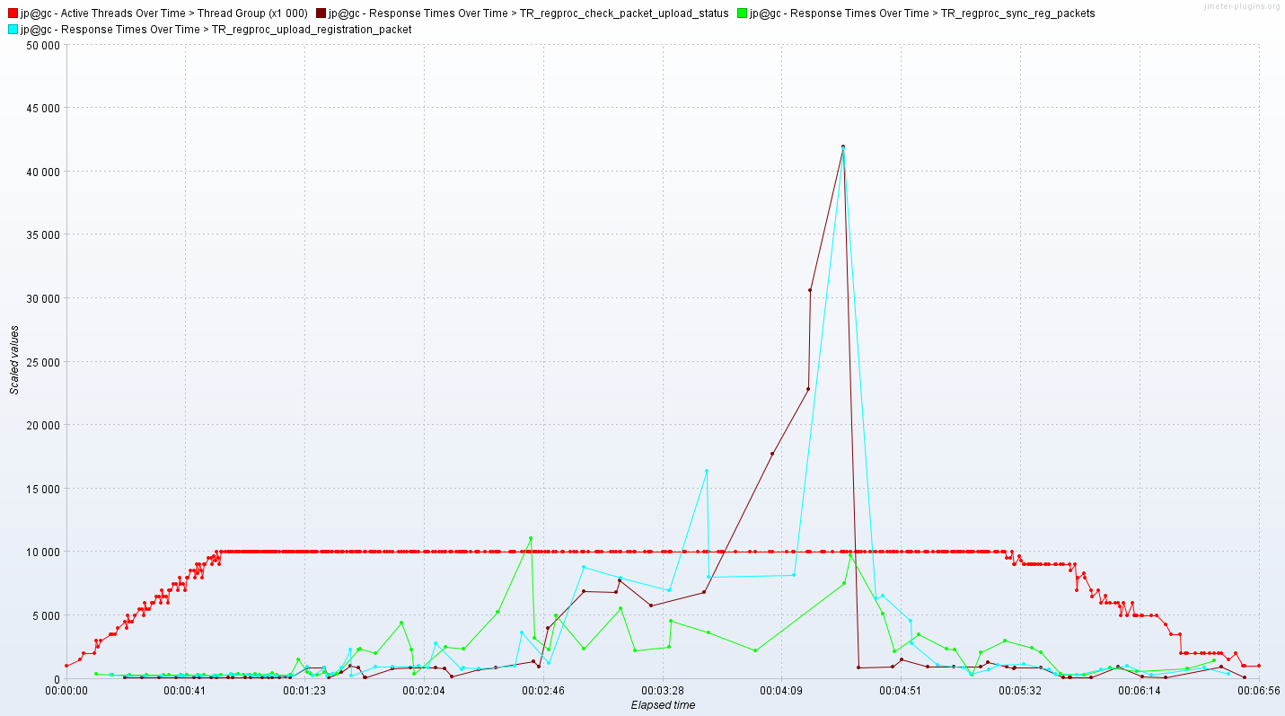

As seen in the above graph, 10 users were active for around 4 minutes.

**Response Time Graph**

Some of the transactions have response time above the SLA (3 sec). Response time has raised high with arrival of users for packet upload and Check packet upload status.

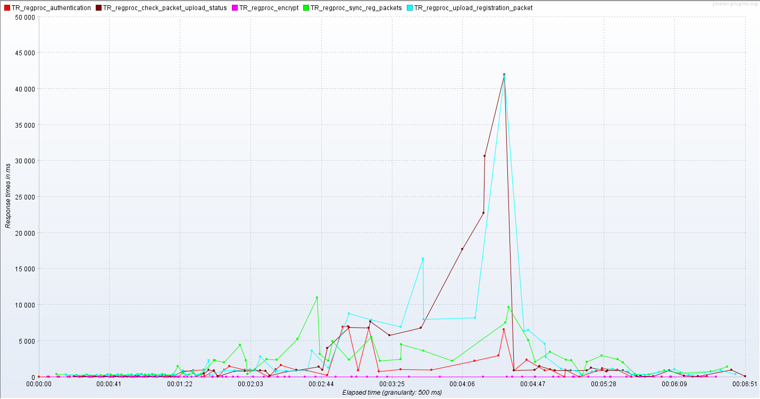

**Resource Monitoring**

Kubernetes nodes were monitored using Prometheus and Grafana from 18th November 06:00 UTC - 09:00 UTC

***aks-agentpool-32091406-0 (VM 1)***

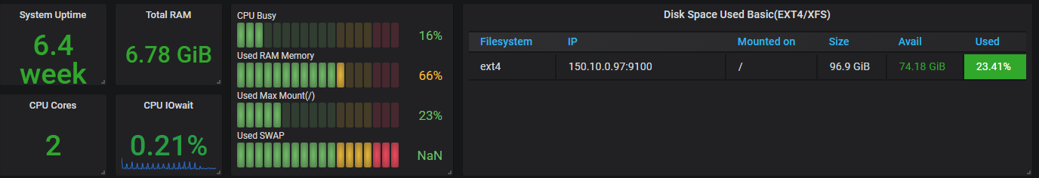

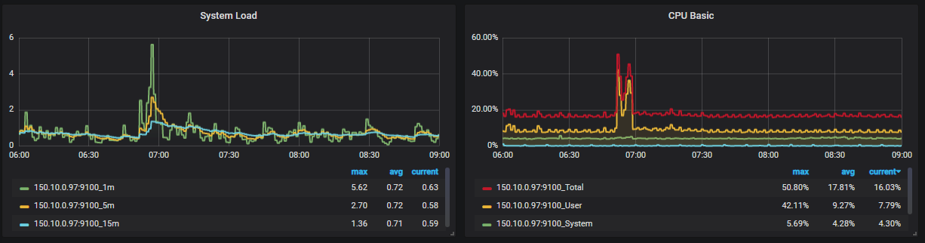

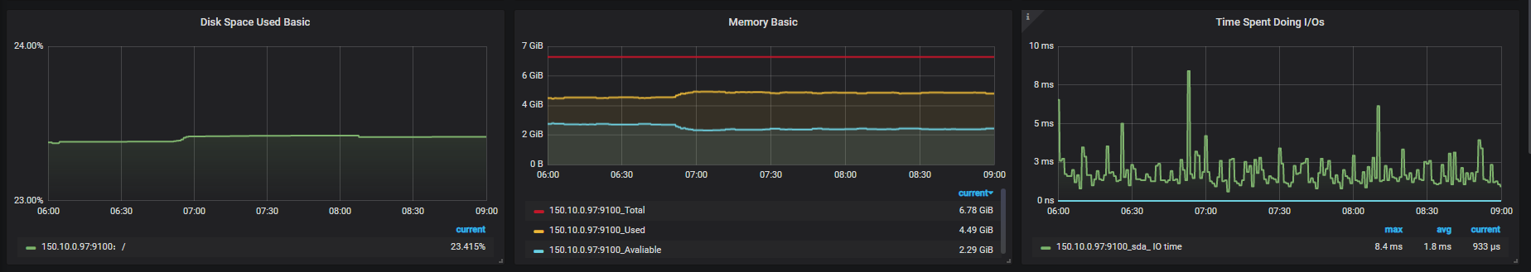

***aks-agentpool-32091406-1 (VM 2):***

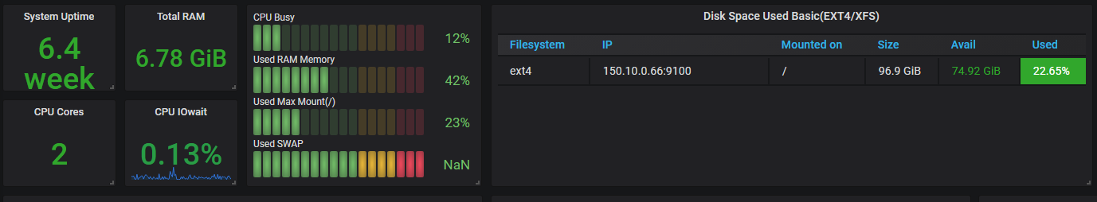

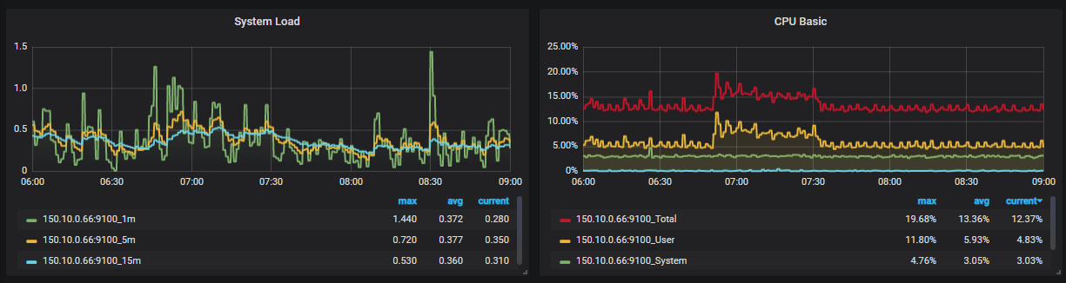

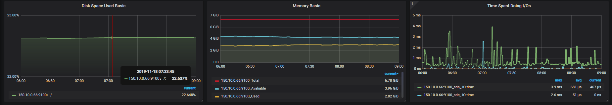

***aks-agentpool-32091406-2 (VM 3):***

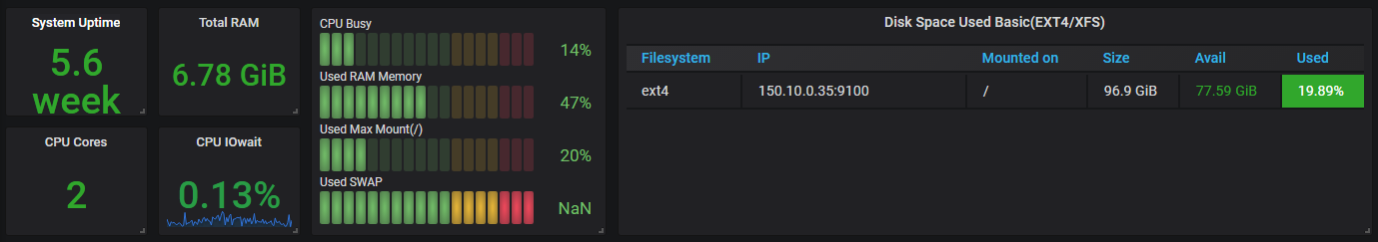

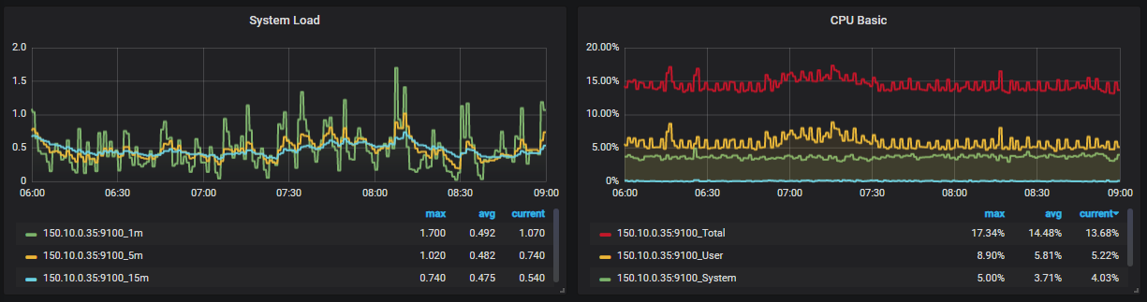

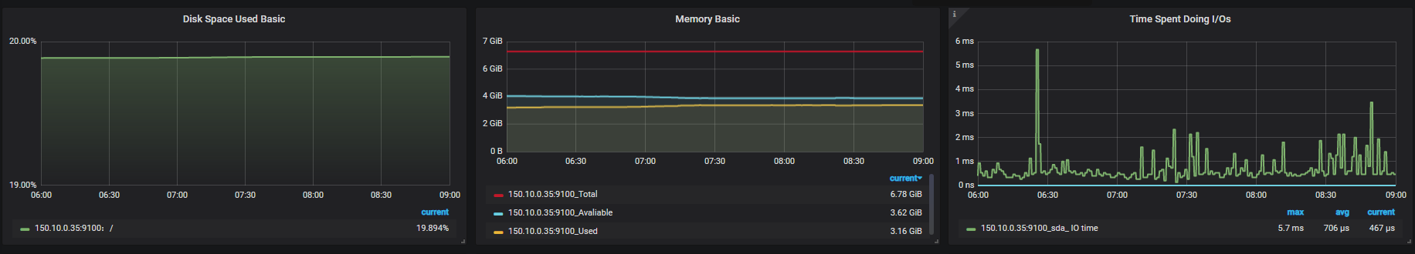

***aks-agentpool-32091406-3 (VM 4):***

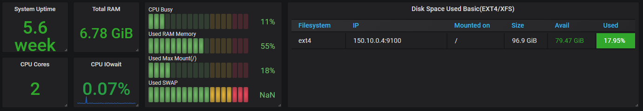

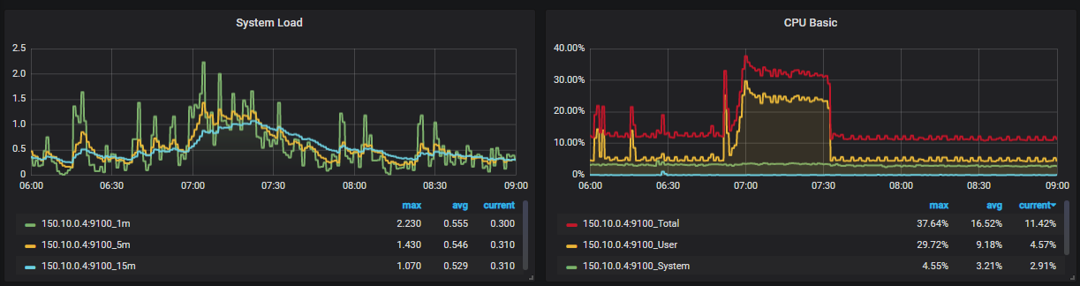

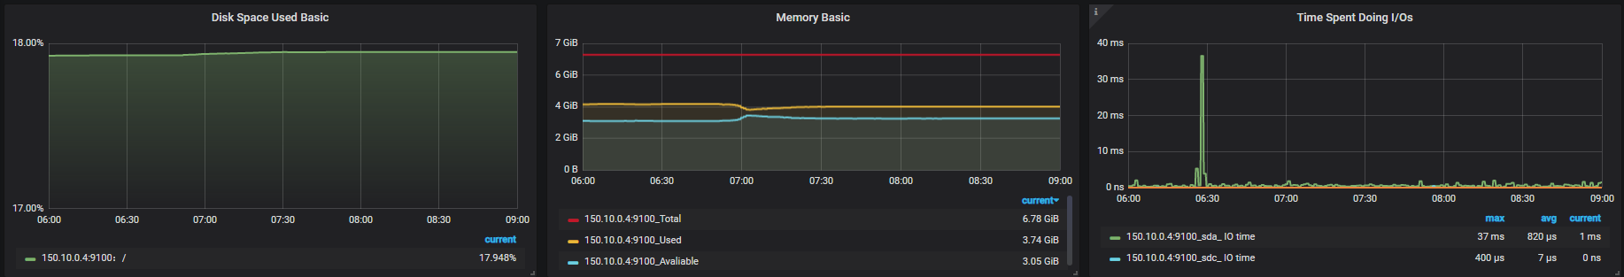

***aks-agentpool-32091406-4 (VM 5):***

